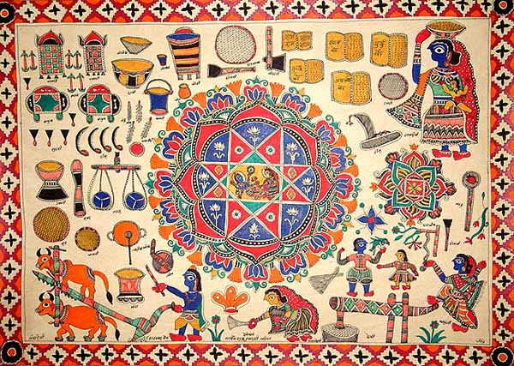

Roots of Jharkhand Tour (4D 3N)

**Day 1 (Ranchi):**

Morning: Pickup tourists and transfer them to hotel for fresh up with breakfast and welcome drink.

Afternoon: Lunch and visit of Audrey House and Jharkhand Kala Mandir with snacks

Evening: Free Evening in a park, and serve dinner

**Day 2 (Hazaribagh):**

Morning: Head to Hazaribagh via Pakri Barwadih by bus and lodge, eat and relax in a hotel post travel.

Afternoon: Visit Sanskriti Museum and Art Gallery and have lunch nearby

Evening: Visit Galwan Valley and Panch Mandir

Night: Rest after dinner

**Day 3 (Villages):**

Morning till Evening: Freshen up and explore nearby villages for authentic experience

Evening: Head to Jamshedpur in bus passing through Ranchi for dinner and snacks

Night: Rest from long journey

**Day 4 (Saraikela):**

Morning: Head to Saraikela from Jamshedpur and post travel have some breakfast

Late Morning till Evening: Indulge tourists into Chhau Dance also by providing hunger needs.

Late Evening: Departure to Jamshedpur, freshen up and drop off tourists at Ranchi Airport.

|  |  |  |
| --- | --- | --- |
| Place | Location | Known for |
| Hazaribagh District | North Jharkhand | Coarse paintings |
| Jiskkath Village | Hazaribagh District | Coarse paintings |
| IISCO Village | Hazaribagh District | Coarse paintings |
| Shandariya Village | Hazaribagh District | Coarse paintings |
| Sahaida Village | Hazaribagh District | Coarse paintings |
| Dhetharige | Hazaribagh District | Coarse paintings |
| Kharati | Hazaribagh District | Coarse paintings |
| Raham | Hazaribagh District | Coarse paintings |
| Saraikela | South Jharkhand (near Jamshedpur) | Chaau Dance |
| Audrey House | Ranchi | Coarse paintings |
| Jharkhand Kala Mandir | Ranchi | Coarse paintings |